LAB #09

Threads: Passing Arguments to Threads



Spring 2023

**CSE-204L Operating Systems Lab**

Submitted by: MUHAMMAD SADEEQ

Registration No.: 21PWCSE2028

Section: C

“On my honor, as a student of the University of Engineering and Technology, I have neither given nor received unauthorized assistance on this academic work”

Submitted to:

Engr. Madiha Sher

(27 May 2023)

Department of Computer systems engineering

University of Engineering and Technology, Peshawar

**TASK 1**

**CODE:**

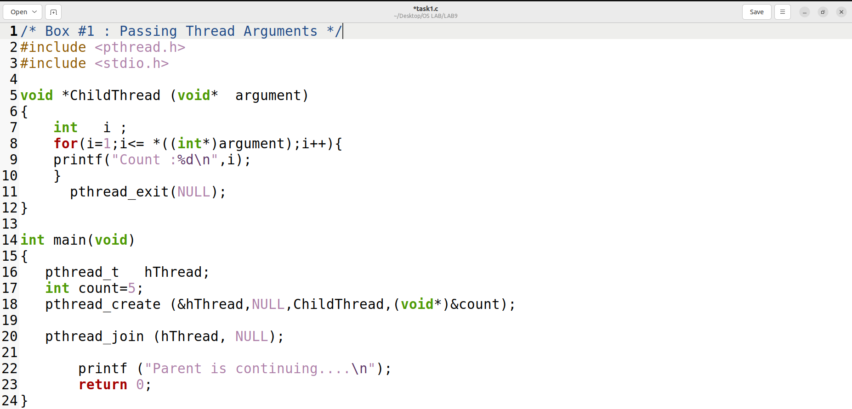

**Output:**

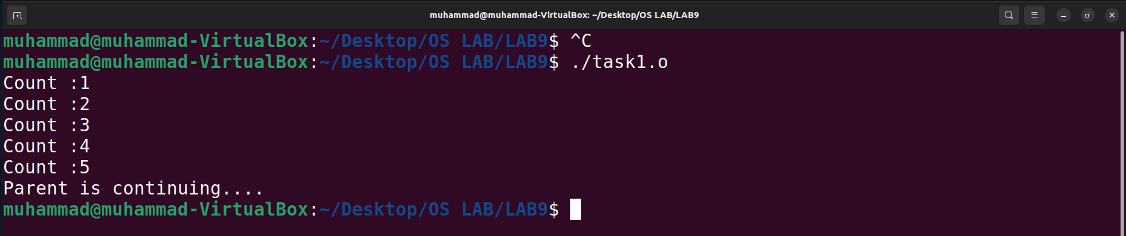

**TASK 2**

**CODE:**

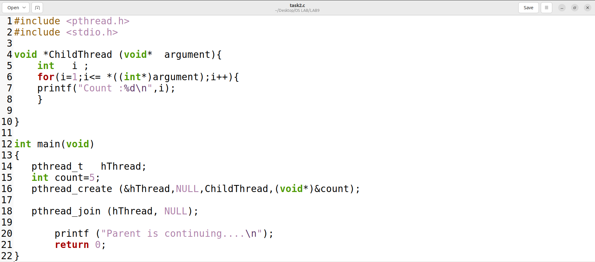

**Output:**

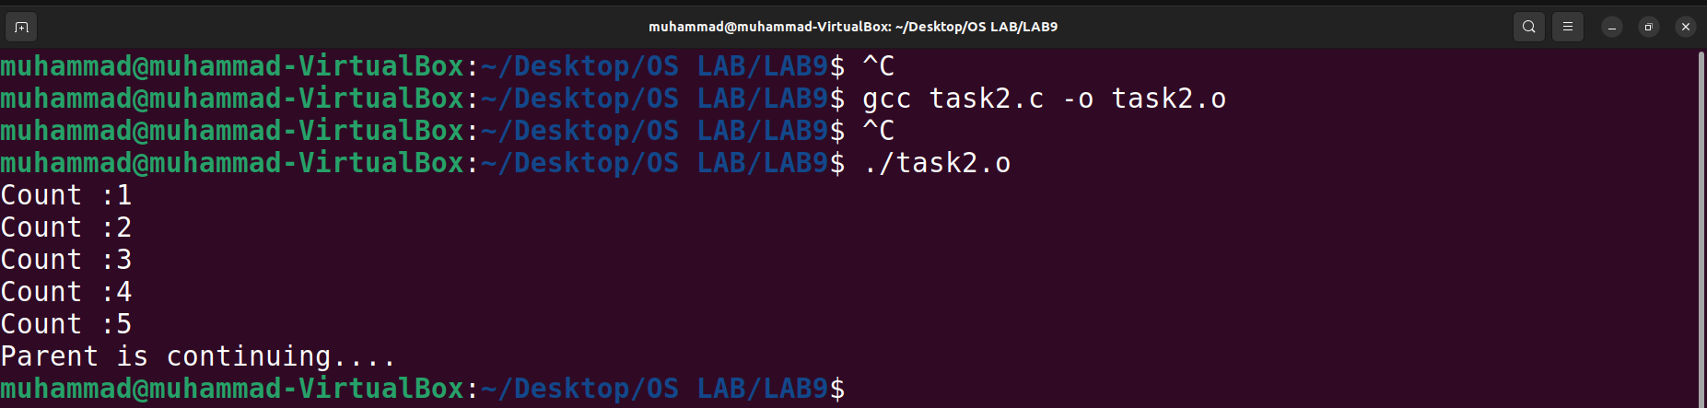

The output is the same as Box #1 because performing a return from the start function of any thread other than the main thread results in an implicit call to pthread_exit(), using the function’s return value as the thread’s exit status1. Therefore, calling pthread_exit explicitly or returning implicitly has the same effect on terminating the thread and making its exit status available to other threads.

**TASK 3**

**CODE:**

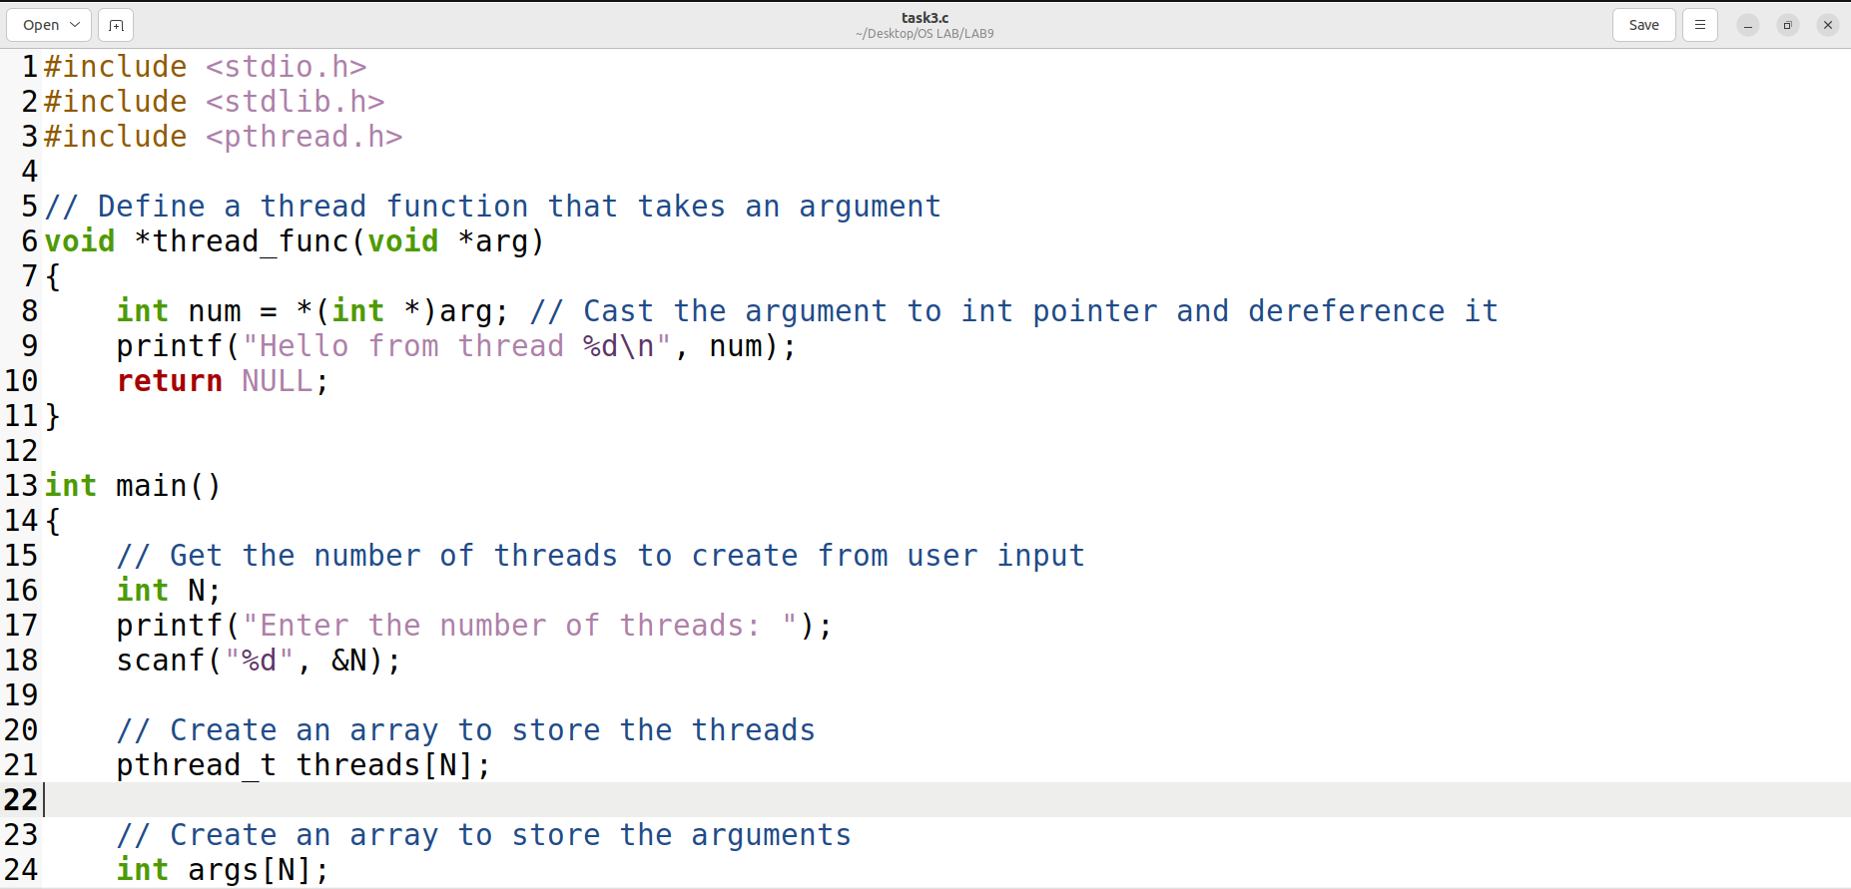

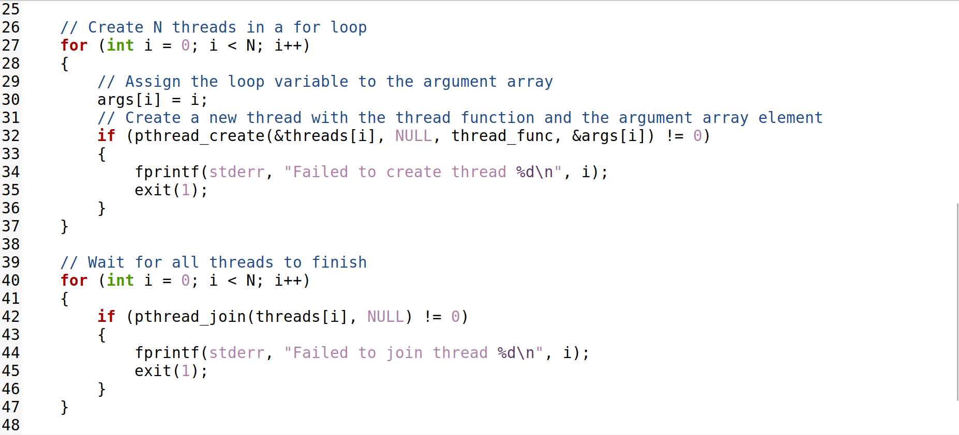



**Output:**

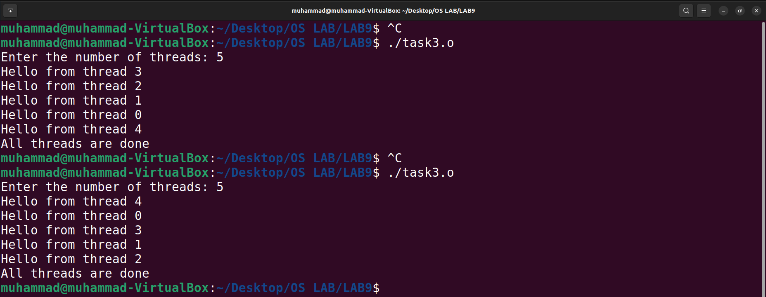

The reason for this variation is that the order of execution of the threads is not guaranteed by the pthread library. The threads may run concurrently or interleaved, depending on how the operating system allocates CPU time to them. Therefore, we cannot predict or control the exact output of this program.

**TASK 4**

**CODE:**

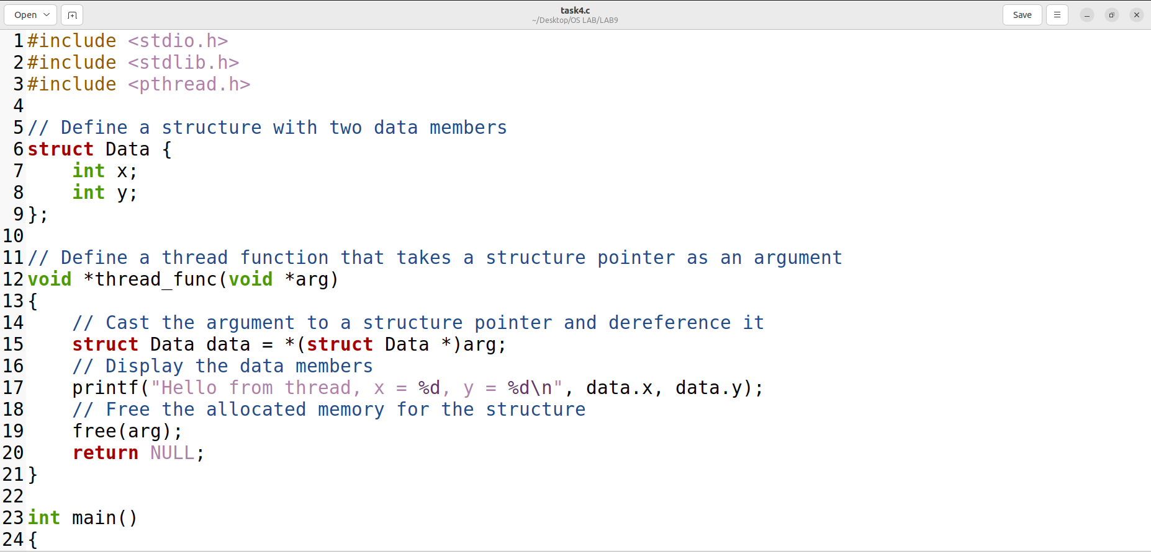

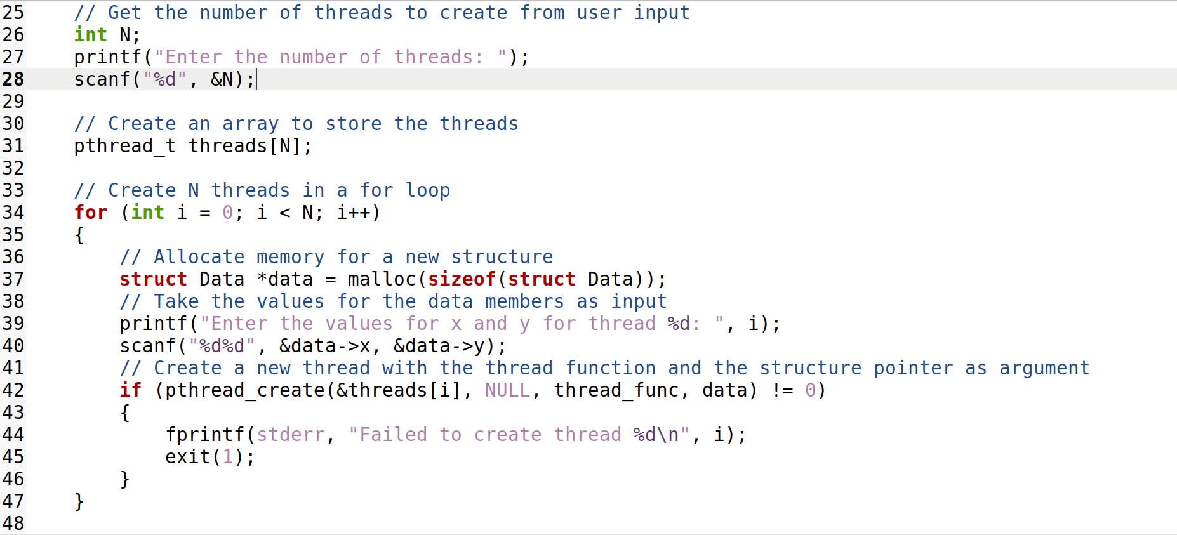

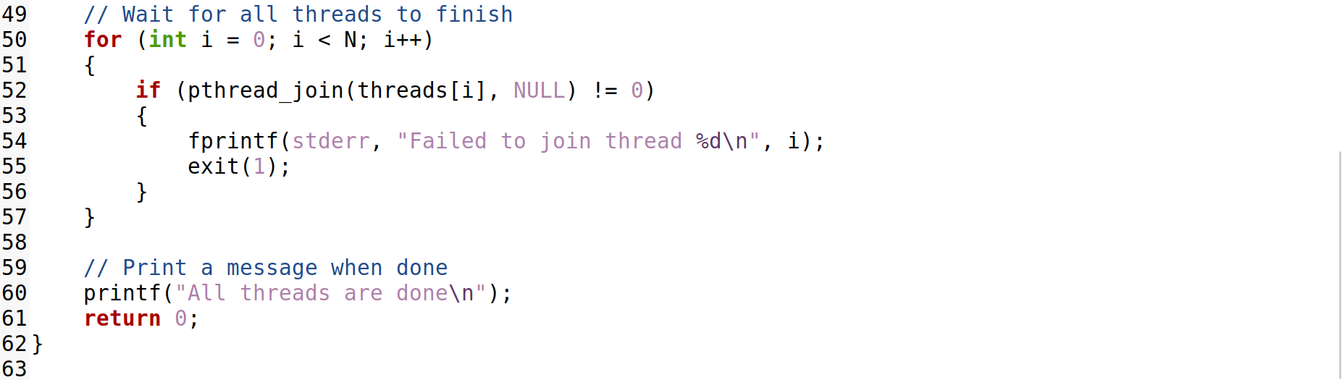

**Output:**

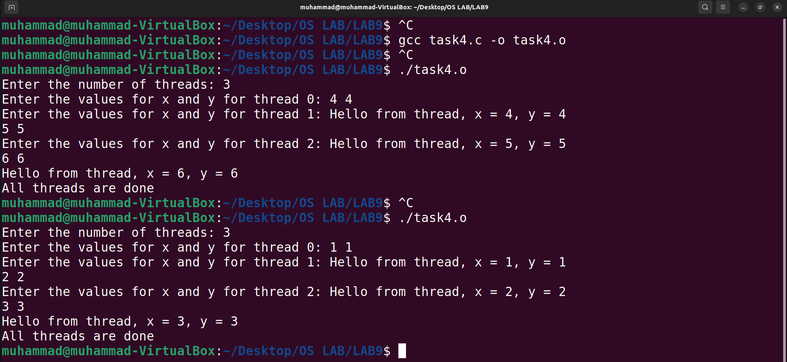

The reason for this variation is that the order of execution of the threads is not guaranteed by the pthread library. The threads may run concurrently or interleaved, depending on how the operating system allocates CPU time to them. Therefore, we cannot predict or control the exact output of this program.